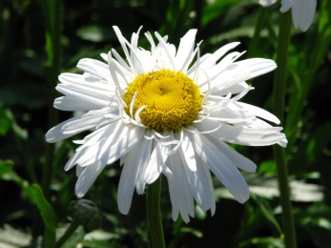
OLD SCHOOL MEADOW
Concern has been expressed to Gurnard Parish Council that dogs have access to all areas of the site including the orchard, play area and wild flower meadow. Also, that some dog walkers fail to clear up after their pets. It has been suggested that some parts of the site should be fenced off, limiting dogs to the main field.
Please indicate your preferences by a tick in the appropriate box below:

Restrict dogs to the main field.
Or
Leave the site as it is.
Or
Other suggestions:

There is also a proposal to upgrade the ‘Mud Kitchen’ and provide more play facilities for younger children. Do you agree?
Yes: |  |  |  | No:

Gurnard Parish Council will need to apply for grant funding to upgrade these facilities.
This form can be found on line at www.gurnardpc.co.uk/old-school-meadow/
Please return your suggestions by the 31 August 2021 by hand or email to:
Mrs Katie Riley, gurnardparishcouncil@gmail.com 11 Bay View Road, Gurnard, PO31 8JF

