Summary of BSWP notes for sharing with GPC at council meeting on 14th December.

The Beach Safety Working Group met on 1st December as had been agreed by the GPC councillors on the group. Unfortunately lead councillor Mark Franklin was unable to attend but the agenda and meeting format had already been agreed so Cllrs Fuller and Acton followed that agreed plan.
We met in the Upper Room at the Woodvale Pub which was kindly provided for the cost of tea and coffee. A venue near the seafront seemed sensible in case anything needed checking. However everyone at the meeting has good knowledge of the area.
There were seven attendees in all: GPC x2, IWC x2 (Iain Donald, newly appointed Public Realms Manager, and Senad Adams), Helen Ralfs (Gurnard resident, Public Health Nurse and representing swimming groups), Robin Leather (new Commodore GSC) and Ben Willows ( CEO UKSA and rep for non-club PWC users). Laura Moran (Gurnard resident and SW employee) and Vicky Spencer (Gurnard resident and EA employee) sent their apologies. Cowes Harbour Commission and Shirley Robertson are advisory members of the group.
The ‘agenda’ was planned to look at the three priority hazards raised by the RNLI report:
• Swimming, inflatables, bodyboarding
• PWC / powered craft / seaside pleasure boats
• Combined Sewage Overflows (CSOs)

The plan followed was aimed at covering three main points around these given hazards:
Item 1.
To gather information on PROBLEMS/RISKS as viewed through the prism of different stakeholders eyes.
This was done by asking all attendees to write their concerns about each hazard as it affected them or their fellow beach users on colour coded notelets.
Item 2
To clarify and, possibly, group under themes, the problems/risks raised. This is to provide an initial approach to possible mitigation.
Some themes were provided as a starting point – Education and Improved Signage came out as the two most important and all three hazards were seen as being affected by these.
Buoying off a swimming area was NOT welcomed by any of the local stakeholder groups including swimmers.
An additional theme was suggested which was to improve co-operation and information sharing between all stakeholder groups.
Item 3
To compile/provide clear feedback to IWC on concerns held by major stakeholders.
Iain able to take away a very clear indication that buoying an area off to separate swimmers from PWC was not seen as a positive move by any of the user groups.
That improved signage would be welcomed and the nature of that signage is something to be discussed further as some existing signage is inaccurate, inadequate, misleading or simply out of date. There is no mention of swimmers as users of the area and this should be rectified.

The item below is an obvious example of just how much up-dating is needed.

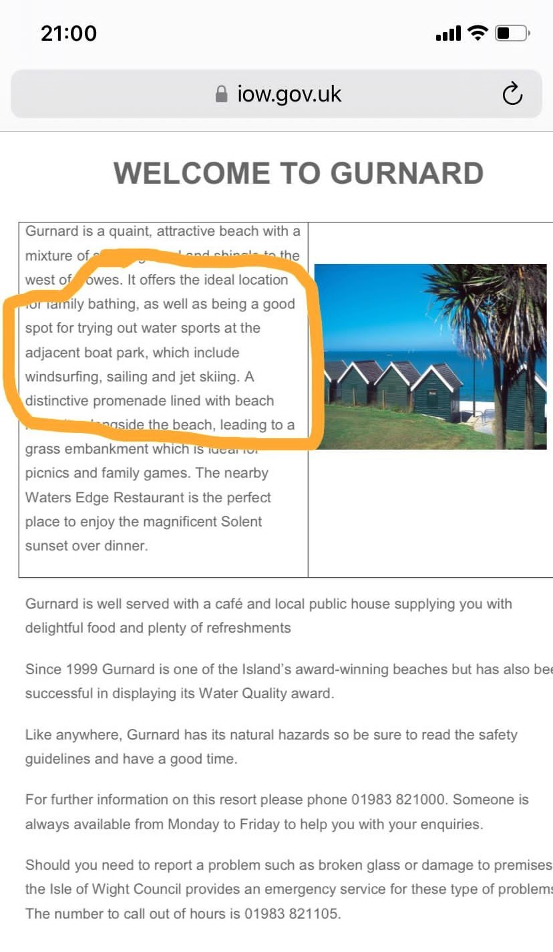

Notes on meeting of Gurnard Beach Safety Working Party: December 7th 2022

Present:
Penny Acton, Senad Adams , Iain Donald, Paul Fuller, Robin Leather, Helen Ralfs, Ben Willows
Apologies:
Mark Franklin, Laura Moran, Vicky Spencer
Copies of these notes will also go to those who have advisory roles: Cowes Harbour Commission, Shirley Robertson.
Attendees had been requested to look at the RNLI report (or the summary produced by Cllr Mark Franklin for GPC) ) in advance of the meeting and to talk with their fellow stakeholders (and other beach users they know about how the RISKS and HAZARDS presented in the RNLI report affect their own particular use of the beach/sea.
Brief introduction by Penny Acton just giving brief background as working party lead, Cllr Mark Franklin, was unable to attend.
Each attendee briefly introduced themselves as not everyone was known to all. Most are Gurnard residents but some had been invited for their professional role - Senad Adams is Environment Officer (and Community Resilience Officer) for the area and Iain Donald is IWC’s newly appointed Public Realms Manager, Ben Willows is CEO at UKSA so has experience of the same risks under consideration and is also a regular user of Gurnard Beach as a sailor /wing-foiler and parent.
Agenda Item 1.
To gather information on PROBLEMS/RISKS as viewed through the prism of different stakeholders eyes.
Three areas of risk were taken from summary report. Each attendee noted risks (or raised points of concern) as seen from their own (and their fellow stakeholders) point of view. Some additions (in italics) came up in discussion otherwise each note is as written at the meeting.
There was some discussion before starting note making on the way the summary gives different emphasis to the dangers represented by PWC. This is categorized in the original report as a LOW-MEDIUM risk area and the RNLI report itself recorded that all existing mitigations of the 80 identified risks within the report were sufficient, other than water quality/pollution and jet skis. However the implication of the summary report suggest all PWC (powered and unpowered) are an area requiring more urgent mitigation. It was noted that in the RNLI report, all assessed risks have adequate mitigating factors currently in place, with the exception of Personal Water Craft (PWC) and water quality. Additionally, the RNLI report does not include non-powered craft in this grouping (i.e. sailing dinghies, foils, wind surfers).

RISK 1. Swimming, inflatables, paddle boarding
Illness ( at least one instance of a child missing a week of school following swimming at Gurnard known. Infected cuts suffered by regular swimmers)
Conflict with personal watercraft ( this area raised large number of comments but is categorized by RNLI report as being a LOW risk.)
Risk of collision with foilers/dinghies and jet skis in particular (High)
Colliding with dinghies/foilers now a year round risk as cold water swimming has become more popular (multiple groups of swimmers now meet at Gurnard)
Contact with other water users
Collisions between swimmers and high performance craft
Swimmers unaware of PWC etc mixing in one small area
Swimmers are not always visible
Swimmers are often not visible. They swim far out into areas where GSC and wing-foilers are. They should have a bright swim float or bright hat on. Swimmers sometimes over-reach their strength and are seen hanging off a buoy while they rest.
Swimmers on inflatables drifting into deeper water
Conflict with on-shore and off-shore litter ( detritus from fishing, dog faeces, sanitary items/condoms and nappies were all mentioned in later discussion)
Disposable barbecues (dangers have been highlighted on National TV)
No life guards
No lifeguard on the beach – holiday makers, weak swimmers
Parental supervision (not always adequate or effective)
Holiday visitors don’t always see signs
Is fishing allowed from beach when swimmers are in the water?
Unable to use all the beach (this was written on a swimming notelet but not 100% sure as to what the concern might be)

RISK 2. PWC / powered craft / high performance sailing dinghies ( SUPs kitesurfing/ foils and wings)
Conflict with other beach users
Contact with swimmers
High speed craft increased danger
Foilers and wing boarders at risk of collision with swimmers especially when in waves and surf when some swimmers still swim year round
Jet skiers , inexperienced riders or holiday makers, riding at speed in main swimming area
Kite-surfers fast and close to shore mixing with swimmers near miss with blade of board
Anti-social behaviour from some (highlighted that it is a very small minority - jet skiers in particular- that behave stupidly)
Non GSC club dinghies visiting from the mainland (or other clubs on the Island for Open Meetings) coming into beach = risk of collision with swimmers
Holiday visitors on jet skis unaware of/uncaring about by-laws etc
Pollution (sailors may not choose to go swimming but they still do!)

Following points related directly to idea of a buoyed area and what impact such a change could introduce:
Most PWC local users are very good. Occasional summer PWC users that are lacking in education will not use a buoyed channel - a buoyed channel would not deter stupid behaviour
There is no-one to police a channel – no lifeguards or marine police
Sailing dinghies not being able to launch safely due to restricted room
A buoyed channel for PWC would not work. It would need to go too far out and would be right in the middle of GSC sailing area (sailing upwind against the tide would be impossible if a line of buoys pushed sailors out into tide)
Sailors not wanting to sail at Gurnard due to feeling unwelcome and over regulated – sailing club fails
People not visiting Gurnard as nothing (much less) to look at, take photos of

RISK 3. Water quality/pollution due (largely) to local Combined Sewage Overflows (CSOs)
Who to trust? Southern Water? Campaigners?
Cowes /Gurnard – highest DRY discharges in the country 2 discharges (CSOs?) plus Jordan and Luck into bay
Impact of private outfalls pouring (?) into water courses
No year round water testing at Gurnard to monitor fluctuations in water quality.
Pool of bubbling brown, steaming water observed x2 observed months ago(Sept/Oct?) in Gurnard Bay near CSO pipe between GSC and the Luck.
SW make no reference to Woodvale CSO in technical report (published Sept 22) other than listing in a table which shows 78 discharges from this point this year
CSOs possibly not only cause of pollution – Jordan Valley can discharge too
Luck River may also add to poo problem
Some properties feeding into Gurnard Luck and Jordan Valley have septic tanks and with rainwater feed into water that goes untreated.
Observed brown release water flowing past Bay (in front of beach huts) (photo evidence)
How regularly is water tested and where are results posted (Swimming App?)
Lack of water testing – bathing water quality is unknown
Cleanliness of beaches
Better reassurance needed concerning pollutants
Pollution from animals (particularly dogs? But also a dead swan and a dead porpoise have washed up in Gurnard Bay in the last month or so.)
Skin and eye infections after swimming at Gurnard
Cases of sickness and diarrhoea after swimming at Gurnard Beach
Illness – possibly related to pollution affecting all ages

RISK 4* The hard standing in front of the beach huts
This is an additional area of risk which was raised at the meeting but is not introduced in the summary (low risk in report) which has a sole focus on the water
Notices not in place (or inadequate or sufficiently visible)
Beryl scooters on path in front of beach huts risk of collision with pedestrians
Cyclists on path – signs unclear
Falling on uneven surface /some concrete old and damaged

Agenda Item 2
To clarify and, possibly, group under themes, the problems/risks raised. This is to provide an initial approach to possible mitigation.
Main sub-headings were themes posed in advance. Notes following are a brief record of discussion.
EDUCATION
Seen as a key theme with multiple aspects - the following are only examples:
- Swimmers need to be visible and follow other basic rules (e.g don’t swim alone) – education and shared self-help between different groups
- PWC users need to know by-laws in force
- Sharing with whole community the positive ways that residents can ameliorate surface run off and the over-loading of the Combined Sewer System. IWC planning and planning enforcement may have part to play too
- Encourage SW to stop the slick presentations which are not engaging or seen as irrelevant and focus on things that are appropriate to the local area.
MORE PUBLICLY ACCESSIBLE COMMUNICATION OF:-
CURRENT BY-LAWS
RULES ABOUT CYCLING ON SEAFRONT HARDSTANDING
GSC EVENTS (notification extended beyond members and brought to the public notice of residents and beach users. Paul offered his Ward Councillor’s bulletin as a platform, Robin already has asked about an advert in Gurnard News -told to keep it brief!
IMPROVED SIGNAGE/INFO BOARDS
Some signage is to be up-dated by IWC anyway but there are some existing signs which are clearly inadequate or missing e.g. No Cycling on hardstanding path or the notices on slipways. If signage is good it makes it easier for the beach user community to self-police.
There was discussion about the advantages of providing positive information boards too – e.g. an environmental boards showing some of the amazing things that are located in Gurnard Bay, some history activities or things to look out for.

SUPPORT FROM SOUTHERN WATER
Encourage all residents in village roads/streets eligible to take up the offer of water butts.
Encourage a positive engagement with any relevant schemes such as https://www.fluidion.com/en/products/alert-lab
Maintain contact with Shirley Robertson and Ben Willows as they work to hold SW to account and to encourage a positive and pro-active approach to Gurnard Beach safety on SW’s part.
ON-SHORE SAFETY EQUIPMENT
The nature of Gurnard Beach means that there is no formal requirement for on-shore safety equipment but a IWC officer (Tricia Stillman ?) worked hard to make sure this was retained and there is a need to appreciate what we have.
BUOYAGE OF PARTICULAR AREAS
This was seen as a detrimental step by ALL local stakeholders which would do little or nothing to improve any risks at the beach.

Closer Co-operation between various users (stakeholders) was a theme that was suggested at the meeting.

Agenda Item 3
To compile/provide clear feedback to IWC on concerns held by major stakeholders.
We all concluded that buoyed channels/zoning would not work at Gurnard and we should focus on improved signage and education for PWCs users and support a self-policing community. There are also further conversations to be had with SW and the environment agency on monitoring water quality.
Iain able to take away a very clear indication that buoying an area off to separate swimmers from PWC was not seen as a positive move by any of the user groups.
That improved signage would be welcomed and the nature of that signage is something to be discussed further.

Agenda Item 4
To agree date for next meeting
Date for next meeting: Wednesday 1st February; Venue to be confirmed. Agenda will be distributed at least a week in advance of the meeting.

Action Points for consideration before next meeting:

Water Quality
Parish Precept Consultation will be completed before the next meeting. Initial returns confirm that concerns about quality of water and (CSO) pollution are widespread . Could be some funding for Water testing from GPC.
- Make closer contact with Faeces Group in East Cowes
- Make closer contact with Bianca Carr – the Clean Harbours Partnership ( Final Straw Foundation )
- Follow up https://www.fluidion.com/en/products/alert-lab – possibly from SW – need training
- Reconnect with Porton? Check quotation still valid.
- Follow up idea of supporting EA to test for more extended period/ throughout the year
Aim to get list of roads eligible for water butts from SW asap.
Check both RNLI and SW Technical Report available and accessible on GPC website
Urgent update needed on Gurnard’s IWC website if this is what is still on site – see below.
Existing signage has spelling errors and makes no mention of swimmers.
While members of the group were asked to join for good reasons and between them represent a large number of the users of the beach there is, and cannot realistically be, any representation from holiday makers. Yet holiday makers certainly add to heavy use and risks increase in high season. Should we consider how we include this ‘group’ in our discussions more widely?

